Attention
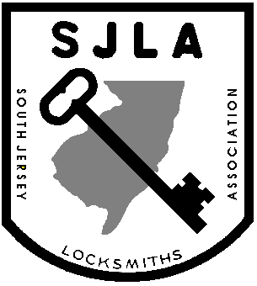

All New Jersey Locksmith Licensee’s

SJLA is sponsoring the Mandatory CEU Classes. These classes will give you 10 CEU credits towards your 2028 license renewal. You will receive 2 certificates.

When: Wednesday, April 29th, 2026
Time: 08:30am – 4:30pm

Location: Wesco Instructor: Tom Demont
7884 Browning Rd Pennsauken, NJ 08109
**Class is limited to 20 people

Price: Members SJLA/GPLA $375.00 Non members $425.00

For Class Info Contact: Bob Cornine @ 609-339-9698

**Payment must be made by April 15th to ensure receipt of your CEU certificate**
Class Starts Promptly at 8:30 am. No one will be admitted after 8:30 am. No Exceptions!!
Must Bring ID and NJ State License to insure CEU Credits

Cut along Line and send bottom portion with check Made Payable to: SJLA
---------------------------------------------------------------------------------------------------------------------------

First Name: ___________________________________ Last Name: ________________________________

Address: ________________________________________________________________________________

Business Name: __________________________________________________________________________

Business Address: ________________________________________________________________________

Contact Phone Number: __________________________ Member # SJLA ______GPLA ______MLA _____

New Jersey License #: _________________________________________________

CC# --------------------------------------------------- --- Exp Date__________ Code_____Name on card_____________________

Make Checks Payable To: SJLA
Mail To: SJLA c/o Bob Cornine, 20 Hogan Court, Little Egg Harbor, NJ 08087
**MAKE SURE YOUR NAME IS LEGIBLE.

